Diagnostic Template

**Name**: Retrospective analysis

**Goal**: A retrospective analysis is used to determine whether there is a misspecification in the estimation model (ICES 2020). It assesses the impact of the most recent years of data on model estimates and determines whether estimated quantities are consistently over or underestimated.

**Description:**

* A retrospective pattern is a systematic inconsistency among a series of model estimates such as population size, spawning stock biomass, or fishing mortality, based on increasing years of data (Mohn 1999).
* Retrospective patterns often arise due to a temporal change in life-history characteristics (e.g., natural mortality, growth), selectivity, or in the accuracy of input data (e.g., fishery removals) that are misspecified in the model (Legault 2009, Deroba 2014, Hurtado-Ferro et al 2015).
* A within-model retrospective analysis is useful for determining an internal inconsistency in the data because the only change between model runs is the number of years of data (Legault 2009).

**How to:** The following steps are necessary for computing a retrospective analysis: (i) run the integrated assessment model; (ii) remove the terminal year of data and rerun the model; (iii) repeat step 2 for a total of at least 5-7 years. Trends in year-specific estimates of abundance, biomass, and mortality can then be compared to results from (i) to determine if they are consistently over or underestimated.

The severity of a retrospective pattern can be evaluated using Mohn’s rho, which is defined as the average of the relative differences between estimates from a model using a truncated time series and estimates from one based on full time series (Mohn 1999, Hurtado-Ferro et al 2015). A positive Mohn's rho value indicates that the estimated quantity is consistently overestimated as years of data are removed.

If a retrospective pattern (consistent over or underestimation of biomass, abundance, and/or mortality) exists, a retrospective adjustment to model estimates can be made. A retrospective adjustment is typically based on Mohn’s rho. For example, $\hat{θ}$ = $θ\frac{1}{1+ρ}$, where $θ$ is the unadjusted value and $ρ$ is Mohn’s rho (see Legault 2009).

**What to do: Regional Practices and Examples**

Retrospective patterns are handled differently among regions.

In the northeast, if a “major” retrospective pattern exists, defined as an adjustment that shifts the terminal year fishing mortality or spawning stock biomass outside the 90% confidence bounds of the original estimates, a retrospective adjustment is applied to model results for determining stock status as well as for projections.

In Alaska, guidance explicitly states that Mohn’s rho in isolation is not cause for rejection of a model or an adjustment but rather to be used in evaluating alternative models (Hanselman et al. 2013). The presence of a large positive Mohn’s rho has been used to justify recommending a more precautionary ABC in some cases.

NWFSC & SWFSC: Retrospective analysis is required for all groundfish and CPS (and CPS?) assessments. Highly migratory species assessments evaluate retrospective patterns, although this is not a formal requirement nor have there been problematic retrospective patterns. Coastal pelagic species assessments generally have short modeling periods (10-15 years) and require strong assumptions on biological parameters. This results in negligible retrospective pattern. However, results of the analysis are not formally incorporated into management decisions. Relatively few west coast groundfish assessments show strong retrospective patterns.

PIFSC: Retrospective analysis is commonly used as a model diagnostic for both integrated assessment models and Bayesian biomass dynamics models at the PIFSC. A typical analysis uses a time period of 5 years of retrospective peels to evaluate whether there is a consistent retrospective pattern for the provision of management advice. Retrospective patterns are evaluated for estimates of spawning biomass and fishing intensity, or fishing mortality, using Mohn’s rho (Mohn 1999) or similar diagnostic (Hurtado-Ferro et al. 2015) as a measure of the strength of the retrospective pattern. The direction and strength of the retrospective patterns in spawning potential and fishing intensity are reported as model diagnostics and also used for management advice. If a retrospective pattern is apparent, then this pattern is reported in the stock assessment report for the provision of scientific advice.

For example, in the 2021 stock assessment of Pacific blue marlin, there were two equally-weighted SS3 models in the model ensemble used for BSIA. Both models exhibited a relatively strong retrospective pattern in recent years, with Mohn’s rho values for spawning biomass and fishing mortality of about rho(SB) ≈ 0.3 and rho(F) ≈ -0.3, respectively. In this case, the conservation advice would include a statement that there is an apparent tendency to overestimate spawning biomass and underestimate fishing mortality, in part due to an unusual decline in Japanese longline CPUE in recent years.

In the Southeast, retrospective analysis is routinely used to assess the consistency of terminal year model estimates. Generally, this analysis is not used as a pass/fail criterion, and results for 5 or 10 year retrospective analyses are presented to managers so they can consider any additional uncertainties when making decisions. If the resulting estimates of derived quantities such as SSB or recruitment differ significantly, particularly if there is serial over- or underestimation of any important quantities, the model may have some unidentified process error, which requires reassessing model assumptions.

**Examples:**

To follow are two examples of retrospective patterns that resulted in the rejection of age-structured assessment models.

Yellowtail flounder (Legault et al 2014): Mohn’s rho for F=-0.68, SSB=2.32, and recruitment=1.24.

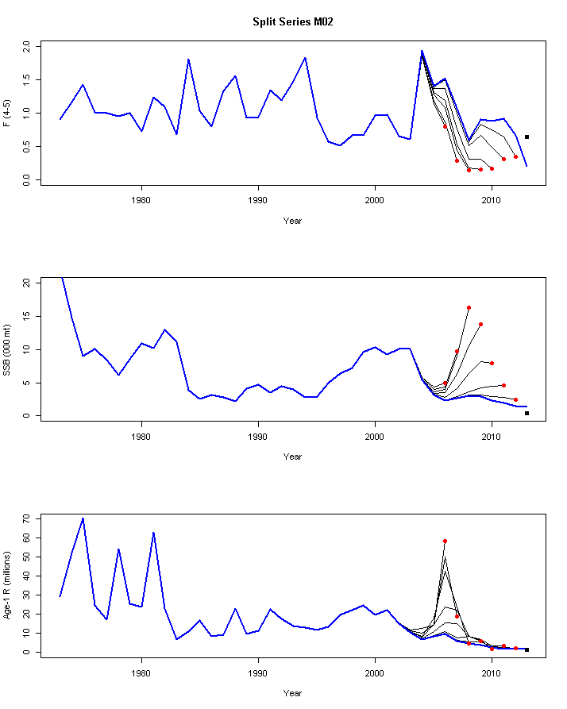

Witch flounder (NEFSC 2016): Mohn’s rho for F=-0.46, SSB=0.64, and recruitment=0.44.

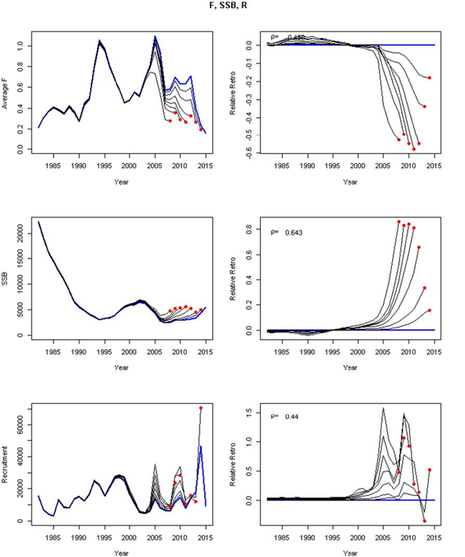

**Recommendations:** 

Do not look at retrospective patterns and results of retrospective analysis in isolation.

The following recommendations and decision tree are adapted from ICES (2020).

1. Always check for the presence of retrospective patterns as a diagnostic tool. The retrospective analysis should extend as far back into the time series as possible, sucho that each retrospective analysis has similar information available for parameter estimation (e.g., time series of stock indices and age compositions are long enough to be informative).

2. Consistent over or underestimation of relevant quantities in a retrospective analysisA retrospective pattern should not be interpreted as a bias because the true values remain unknown, unlike aare not known (only in simulation are true values known); instead, it should be called a retrospective pattern. Likewise, any changes made should be called a retrospective adjustment instead of(as opposed to a correction).

3. Determine if a stock assessment exhibits a major or minor retrospective pattern using. Complete 5-year analytical peels. For stocks that do not have thresholds defined through stock-specific simulation analysis (see research recommendations below), a major retrospective pattern would be indicated by rho > 0.2 or < -0.15 for long-lived stocks, > 0.3 or < -0.22 for short- lived stocks, or 2/3 or 3/5 years with peels outside of the confidence intervals following Hurtado-Ferro et al. 2015 (Ssee decision tree chart below). Mohn’s rho should not be evaluated in isolation; instead scientists should consider additional diagnostics such as, but not limited to, residual patterning, convergence diagnostics, fits to indices, correlations between estimated parameters, parameter boundary issues, likelihood profiling, and an extended series of retrospective peels (to examine patterns in the context of stock trends or changes in data, model assumptions, fisheries). While it is difficult to pinpoint retrospective trends to specific causes, it can be helpful to plot key parameter estimates over the retrospective peels such as catchability and natural mortality, as they can be a major part of serial patterns in results. Examine retrospective analysis of several estimates (spawning stock biomass, recruitment, fishing mortality, and abundance-at-age).

4. In the event a model exhibits a major retrospective pattern, consult the retro action list (see Figure 1below) to evaluate possible causes and modelling resolutions.

5. When a major retrospective pattern results in overestimates of SSB being consistently overestimated (a positive Mohn’s rho) and underestimates of fishing mortality (F is consistently underestimated), adjusting catch advice is recommended (Figure 1 and Legault and Brooks, 2009).

6. Make use of the decision tree (Figure 1) as guidance for identifying a mechanism for providing advice.

7. If there is a major retrospective pattern with robust temporal trends in the assessment quantities across the full time series derived from an age-structured assessment but only the scale is uncertain, then the assessment should be evaluated as indicative of trends, but not scale, in fishing mortality, recruitment, and biomass.

8. Continue to develop a framework/rubric for determining the appropriate rule of thumb for Mohn’s rho for a particular stock (i.e., determine what level of retrospective pattern is acceptable). It should be noted that a stock specific rule-of-thumb should account for the effect of data quality/quantity, species life -history, and modelling approach. Any change in these sources (future assessments) could potentially lead to the need to reviserevising the rule-of-thumb for that stock. This implies that the rule-of-thumb might not be static and should be re-examined whenever possible in the event of substantial changes in data collection, or model specification.

9. Continue to improve the modelling of retrospective patterns in MSEs . Where there are retrospective patterns in athe recent assessments, consideration should be given to including this in management strategy evaluationsthe MSE simulations to. This would ensure that the resulting harvest control ruleHCR is optimized to use in an assessment model with theis realized level of retrospective pattern. However, such MSEs require an understanding of plausible sources of retrospective patterns.

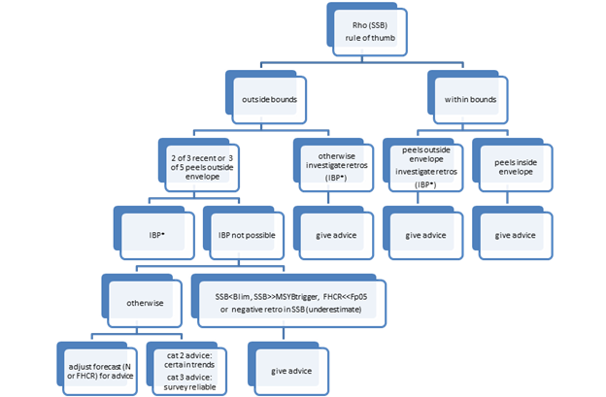

**Figure 1:** Decision tree for handling assessments with retrospective patterns. In the case of an Interbenchmark Protocol (IBP), repeat the process of checking for retrospective patterns as outlined in this decision tree. From ICES (2020).

**Key Literature:**

Deroba, J.J., 2014. Evaluating the consequences of adjusting fish stock assessment estimates of biomass for retrospective patterns using Mohn’s rho. North American Journal of Fisheries Management, 34: 380–390.

Hanselman, D. H., Clark, B., Sigler, M.. 2013. Report of the groundfish plan team retrospective investigations group, 12 pp. <http://www.afsc.noaa.gov/REFM/stocks/Plan_Team/2013/Sept/Retrospectives_2013_final3.pdf>.

Hurtado-Ferro, F., Szuwalski, C. S., Valero, J. L., Anderson, S. C., Cunningham, C. J., Johnson, K. F., Lican-deo, R., McGilliard, C. R., Monnahan, C. C., Muradian, M. L., Ono, K., Vert-Pre, K. A., Whitten, A. R., Punt, A. E. 2015. Looking in the rear-view mirror: bias and retrospective patterns in integrated, age-structured stock assessment models. ICES Journal of Marine Science, 72: 99–110.

ICES. 2020. Workshop on Catch Forecast from Biased Assessments (WKFORBIAS; outputs from 2019 meeting). ICES Scientific Reports, 2:28. 38 pp. <http://doi.org/10.17895/ices.pub.5997>

Legault, C. M. 2009. Report of the retrospective working group, January 14–16, 2008, Woods Hole, Massachusetts. National Oceanic and Atmospheric Administration, National Marine Fisheries Service, Northeast Fisheries Science Center Reference Document 09-01, Woods Hole, Massachusetts. Available: http://www.nefsc.noaa.gov/publications/crd/crd0901./ (February 2014).

Legault, C. M., Alade, L., Gross, W. E., Stone, H. H. 2014. Stock assessment of Georges Bank yellowtail flounder for 2014. TRAC Ref Doc 2014/01. 214 pp.

Mohn, R. 1999. The retrospective problem in sequential population analysis: an investigation using cod fishery and simulated data. ICES Journal of Marine Science, 56: 473–488.